[**VISUAL PHYSICS ONLINE**](http://www.physics.usyd.edu.au/teach_res/hsp/sp/spHome.htm)

**MEMORY MIND MAPS**

**PHYSICS IS FUN, EXCITING, SIMPLE**

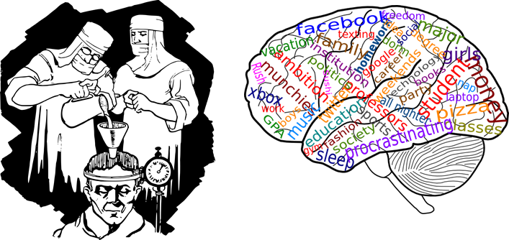

[Mechanics and Special Relativity](http://www.physics.usyd.edu.au/teach_res/hsp/u5/mm92.pdf)

[Electricity and Magnetism](http://www.physics.usyd.edu.au/teach_res/hsp/u6/mg931.pdf)

[Electromagnetism and induced emfs](http://www.physics.usyd.edu.au/teach_res/hsp/u6/mg932.pdf)

[Electromagnetic radiation and the Atom](http://www.physics.usyd.edu.au/teach_res/hsp/u7/t7_mm.pdf)

[Electromagnetic waves, Models of the Atom and Nuclear Physics](http://www.physics.usyd.edu.au/teach_res/hsp/u8/mm98A.pdf)

School, studying, learning, remembering, understanding, homework, examinations and years of it. It is always occupying your live. So, wouldn’t it be great to find a way to make studying easier and more enjoyable with better marks, and spending less time at it !!!

**LESS TIME STUDYING AND BETTER MARKS !!!**

**Too good to be true? No, too good and too true !!!**

The above is taken from the book, *Lana Israel’s Brain Power for Kids: How to become an instant genius*. written by a 13 year old

girl living in Miami, Florida.

The brain is the most powerful and amazing of all computers, but it does not come with an instruction manual. Recently researchers have discovered some very interesting facts about the workings of our brain.

The brain is divided into two parts which are connected by a complicated series of nerves called the **corpus callosum**.

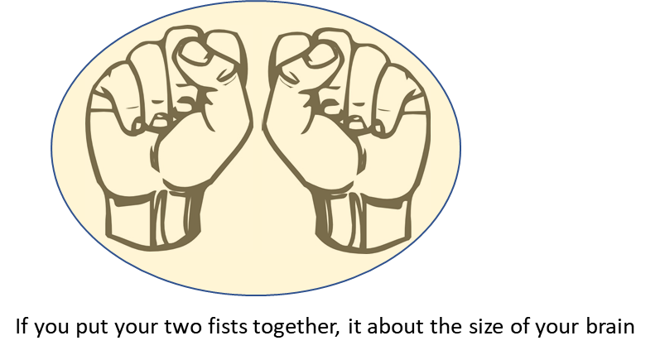

The two sides are known as the left and right hemispheres or **left brain** and **right brain**. The left brain basically controls the more academic activities, whereas, the right brain is for the more artistic activities.

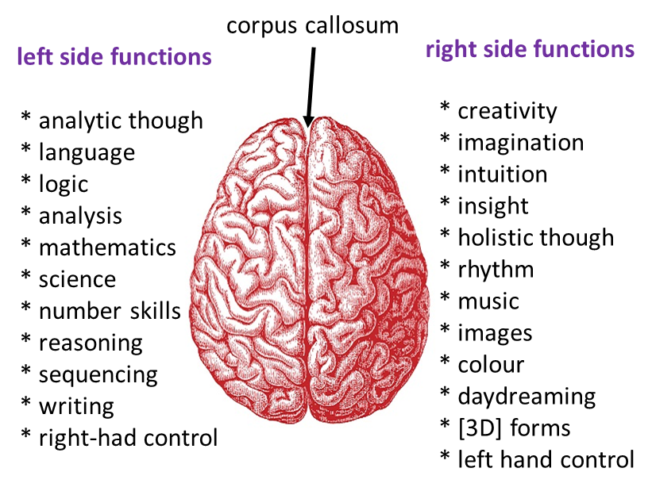

**What does the brain have to do with how we learn?**

**What does how we learn have to do with the brain?**

The way our brain works plays an important part in how we learn. In our schooling, most of the time you are taught to learn linearly, in a linear style or line-like fashion, Books are written linearly, your notes and summaries are most likely composed in a linear fashion, one word after the other.

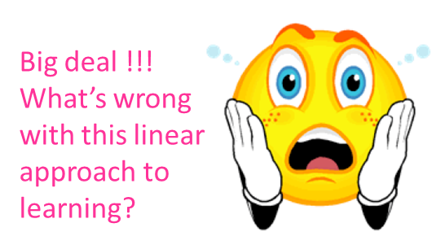

The problem is that currently we use linear methods of learning but the brain does not work linearly, but in a series of links and connections. We are currently **learning how to lean** in a way that does not suit and satisfy our brain. Also, linear styles of learning only use the left side of the brain.

But, there is a way to learn more effectively using both sides of the brain and in a series of links and connections. I called it **Memory Mind Mapping (MMM)** (like concept maps or mindmaps).

A MMM is a map that your mind can use to **collect**, **store** and **retrieve** information. MMM are mental maps, actually set up the way our brain is set up. So, by learning how to make and read them will lead to amazing paths and unlimited brain power.

**Exercise**: Give yourself three minutes to write an article on cricket (or your favourite activity). Now, give yourself another three minutes to construct a MMM of your favourite activity without any padding words using key words, links, pictures and colour. It is **most important** that you do this exercise. You will soon discover that you can convey an enormous amount of information in three minutes with your MMM, but not much information in the linear form of word after word in your traditional written article.



**Advantages of Memory Mind Maps**

* The main ideas are focused and emphasised.
* It is set up the way the brain is set up.
* It works in a series of connections.
* Uses the process of both the left and right sides of the brain (linear methods only use the left side).
* Structure makes recall or remembering easier.
* Use only key words, images and connections (grouping) so recall is stronger and time is not wasted (linear sentence methods waste ~90% of your time writing and re-reading non-key words).
* Does not restrict your thinking like linear methods which are structured in a way that restricts the brain from expanding.
* Makes it easier to see how ideas are related.
* Quick and easy to read over.
* Additions can be made easily. You MMM should evolve as you gain a better understanding, items can be deleted, added or re-arranged.
* Enables ideas to flow.
* Ideas can be easily connected.
* Like a map, much information can be captured on one page. For example, with a good MMM >10 pages from a physics textbook can reduced to a single page.
* In making your MMM, you have to make decisions and process information. When you make linear summaries, very little decision making or processing of information is done.
* Optimises your brain’s potential.

**How to make your Memory Mind Maps**

**A Memory Mind Map should fill one A4 page**

I will provide you with some of my MMM, but making them yourself is much better. Below is an example of a MMM on mechanics. It contains information that would found in several sections of a physics textbook.

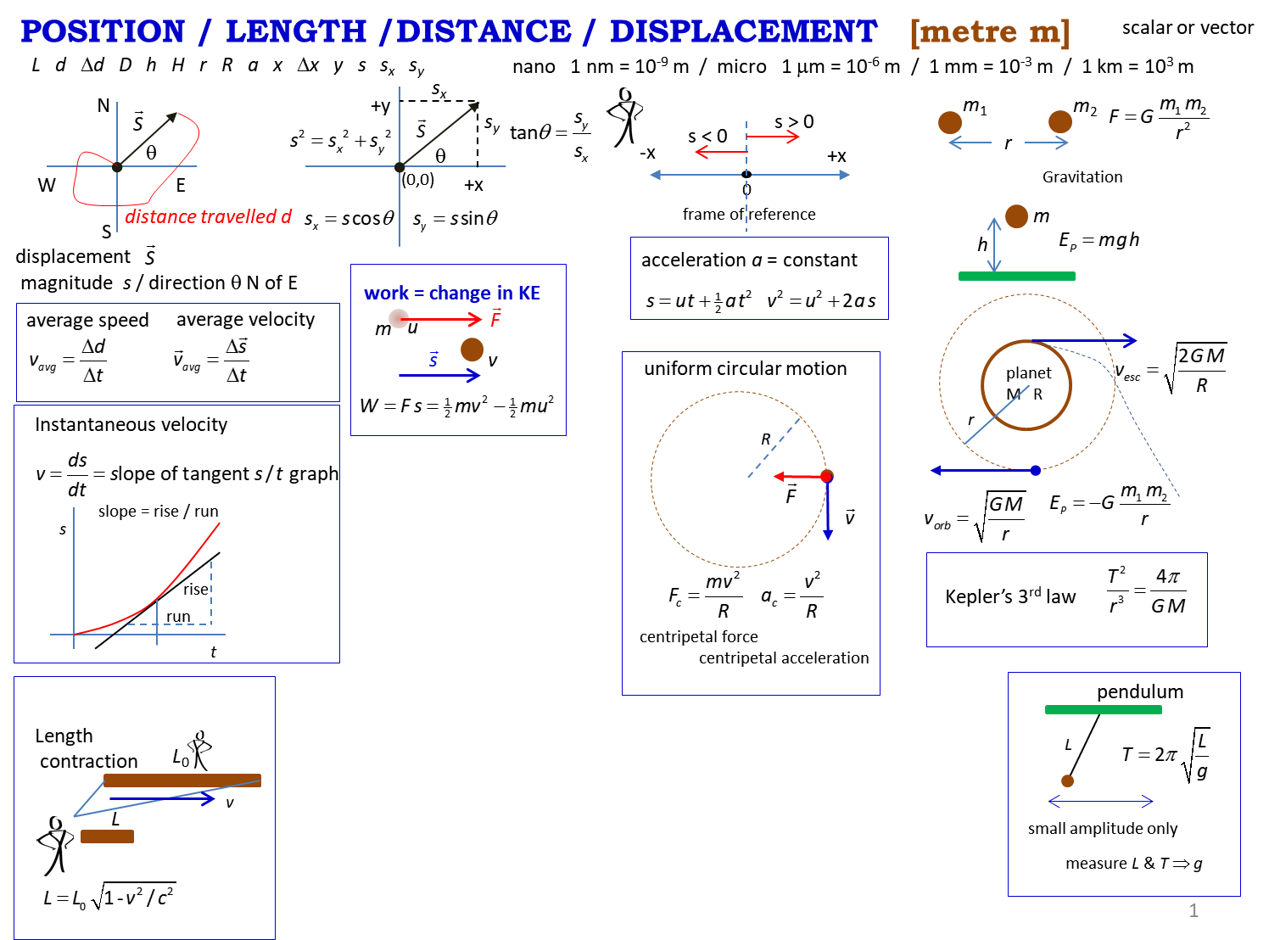

* Clearly show that main concept.
* Identify key words and connections or groupings
* NO padding words (and, the, … ), NO sentences.
* Include symbols, equations, units
* Use graphs to interpret mathematical relationships.
* Use pictures instead of words to convey the meaning of concepts.
* Use colour to emphasis major points. Colour can assist recall and help in the processing of information.
* Use pictures to process information and to make it easier to recall information.
* The MMM are very different from the traditional concept map with just key words linked together.
* MMM should continue to evolve as you add, delete and edit them.

**How to use your Memory Mind Maps**

Your own MMM maps are better than the ones I provide since, you need to make the decisions of what goes on the single page and how it will be organised. You do more processing of the information which stimulates both sides of the brain and improves your brain power.

It may take a lot of time and effort to produce your initial MMMs, but once completed they are a valuable asset. You need to review your MMM often and always use them when studying and doing questions and problems.

For example, you are given the problem

Calculate the height of a cliff, if a ball dropped from rest takes 10 s to reach the ground below.

Find you MMM on uniform accelerated motion and use it to help you find the answer to the problem. Remember the answer is not important, what is important is your knowledge and understanding. This is enhanced by using your MMM.

Memory is a very important part of the learning and understanding process. You should review your MMM for short periods, even a few seconds when watching TV, sitting on the toilet, just before you go to bed, just after you get up, when you are on the bus. With a MMM you don’t have to read it. The information on the MMM goes into your short term memory and by repeated review, the information will be transferred to your long term memory. In an exam, you will be able to visualise your MMMs and be in a much better situation to successfully answer the questions.

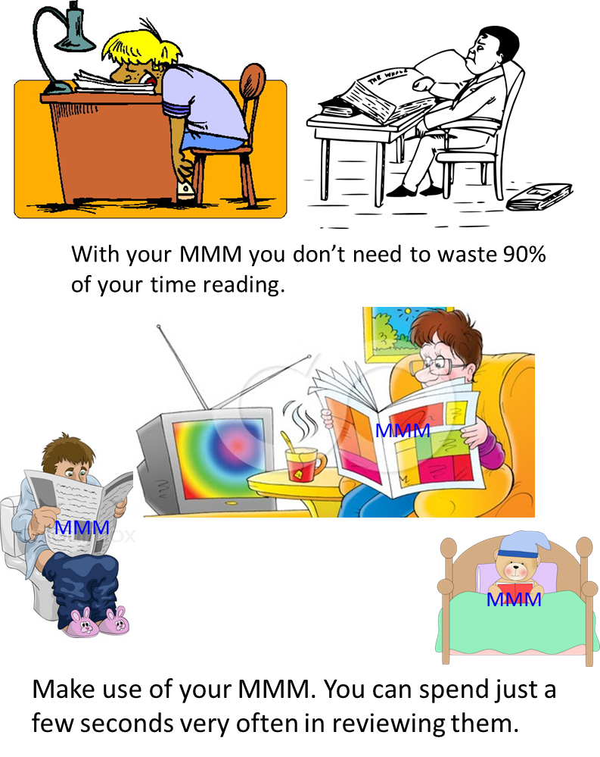

**Memory**

How true is the statement:

“*How little I remember of the things I am learning in school*”

Memory is the basis of all knowledge. We only know what we remember (and sometimes we don’t remember much). 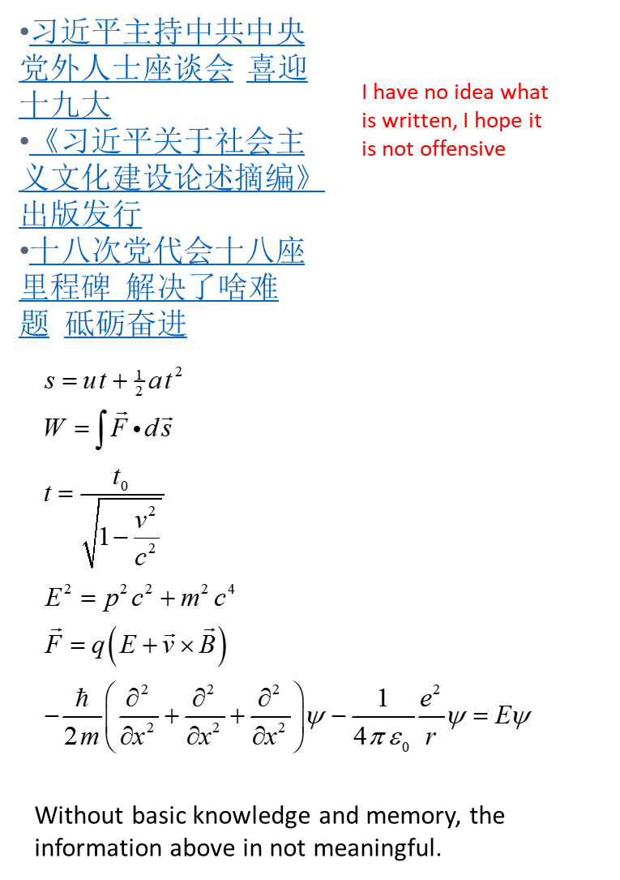

Some [people](https://en.wikipedia.org/wiki/List_of_people_claimed_to_possess_an_eidetic_memory) have amazing memories. But are they smarter than us? Not necessarily. They often have developed a process (or scheme) for not forgetting information. To improve your memory, knowledge and understanding, you need to exercise your brain.

We humans have two attributes which are the most important aids in the process of improving your memory. These are the ability to form **mental pictures**, and the ability to **associate** (link) pictures with each other.

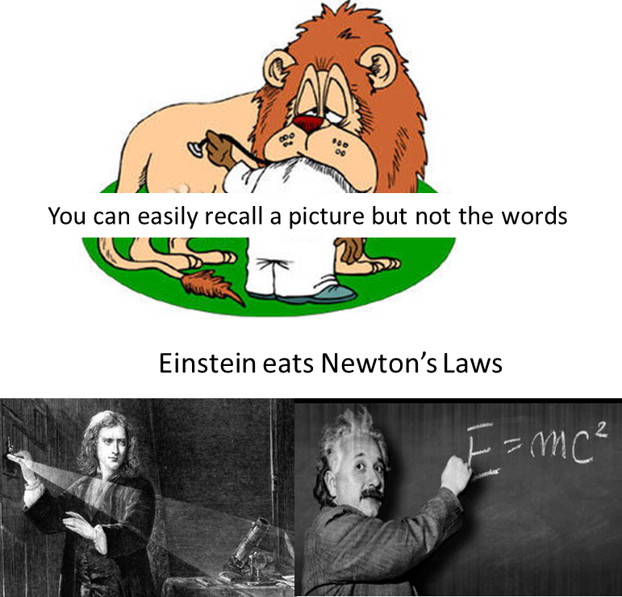

For example, you here a funny story. Creating a set mental images will help you remember the story. The best images are those that distort the experience or are highly illogical. Even the mere act of thinking about the images has a practical and positive effect on the brain. Linking images together and forming associations in very important in the memory process.

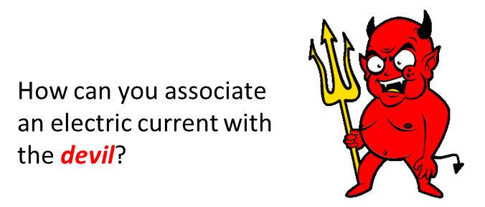

You form a set of **mental hooks** to store and retrieve information by making association between the hooks.

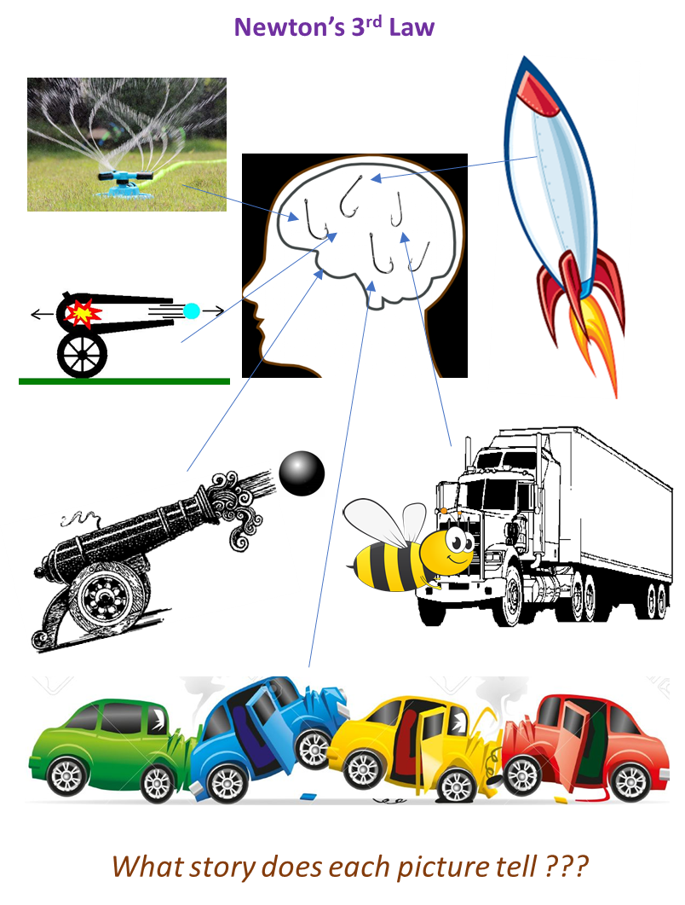

**Note for teachers**

The days of a teacher writing on a blackboard and students copying what you have written should be a thing of the past. There are much better approaches. I once had a class of nearly 100 students doing a physics course in an Agricultural Science degree. Physics for them was not going to be a good experience for them?. The tradiational format was three, one-hour lectures per week. I replaced one class per week with a mindmap session. Students were placed in groups of three (working in groups of 3 has been shown to be more effective than pairs). They were given an article (some article had lots of “heavy” material in them). The group togther using an A3 sheet of paper constructed a mindmap of the information in the article. These students made good use of colour and drawings. By the end of the course they were better at producing mindmaps them myself. Also, for assessment taks rather than complete standard physics problems, they completed individual mindmaps on an A4 page. I have no scientifc evidence to support my following claims;

* Students performed better on answering question that related to mindmap sessions compared with the traditional teacher centred lecture.
* The quality of their answers on avergae were better than the average repsonse for students doing the Physics 1 course.

Another example: I taught a class for science teachers doing their Dip.Ed.. They had three minutes to construct a mindmap on electricity. Within three minutes I new their background very well. Some concentrated on washing machines, stoves, hair dryers, others, mentioned inductors, capacitors , LC circuits, magneitc field, … .

Students can learn a lot through assessment exercises (not formal ones). You can implement regular testing of topics in class. For example, students can construct a mindmap on Newton’s 3rd Law within five minutes. Since you as teacher, don’t have to read much, almost at a glance, you can award a mark for each student ( I managed to mark many Ag science students mindmaps very quicky). Also, the class can review, discuss and reflect upon the many mindmaps constructed by the whole class.

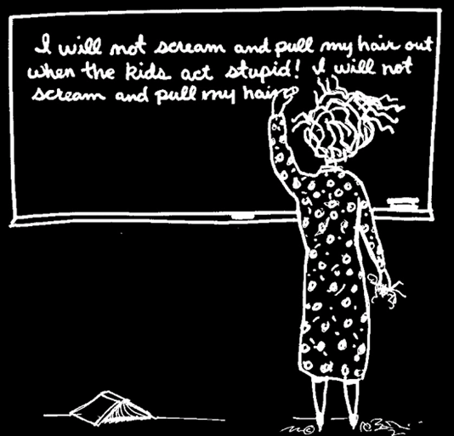

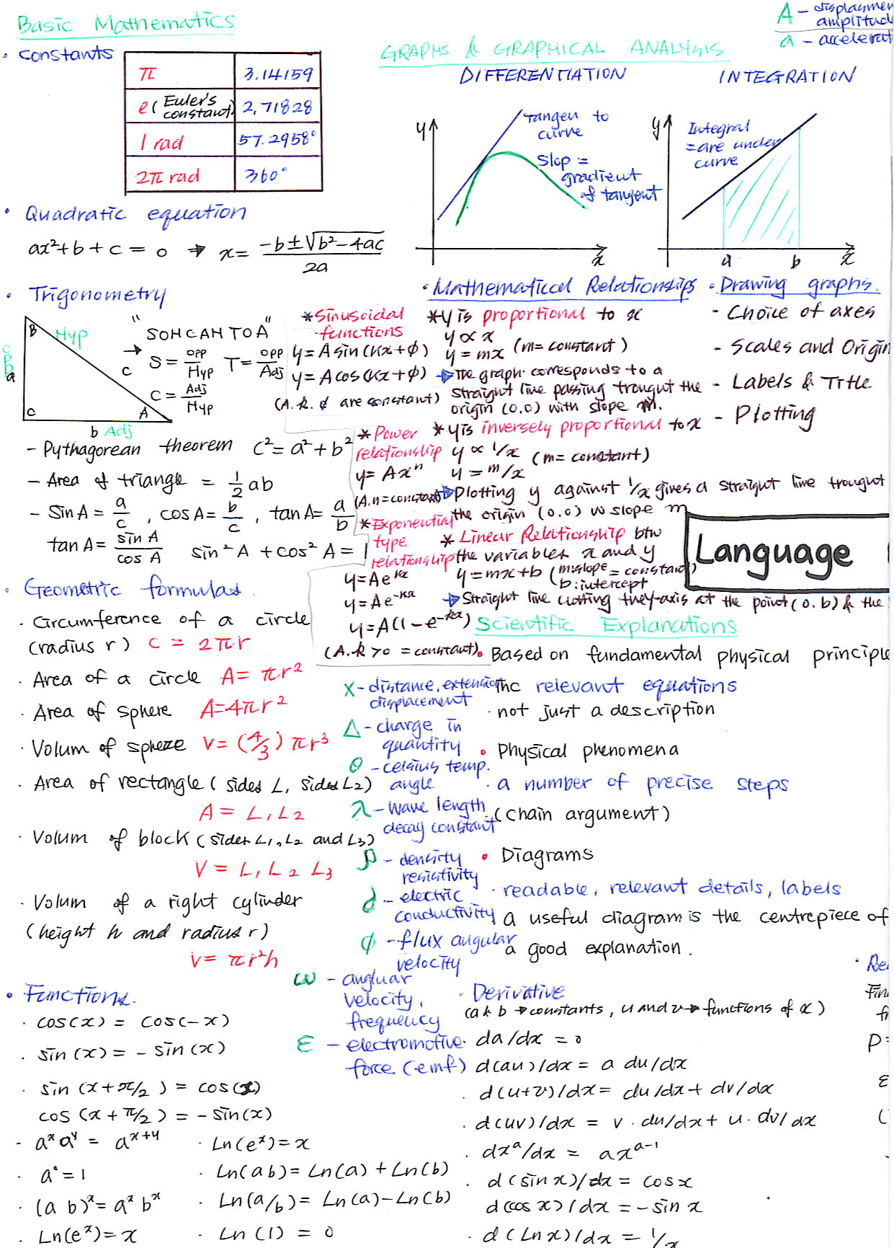

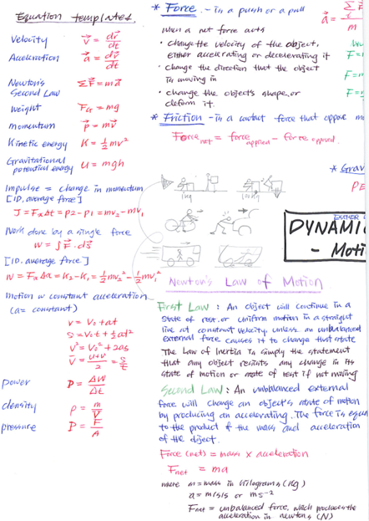

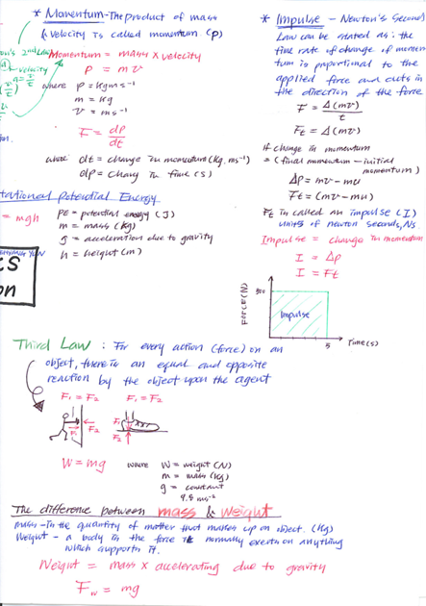

[VISUAL PHYSICS ONLINE](http://www.physics.usyd.edu.au/teach_res/hsp/sp/spHome.htm)

http://www.physics.usyd.edu.au/teach_res/hsp/sp/spHome.htm

If you have any feedback, comments, suggestions or corrections please email:

Ian Cooper School of Physics University of Sydney

ian.cooper@sydney.edu.au